

IBM DATA ANALYTICS INTERNSHIP ASSIGNMENT-1

K KHYATHI VARSHINEE

21BCE7209

Lecturer-Indra Sir

Now the table changes that I have done

1. I have deleted the Invoice ID

2. Make a new row by the formula Original Price = Total-quality\*unit value

3. Split the Date into Year Month Date Week

Output-

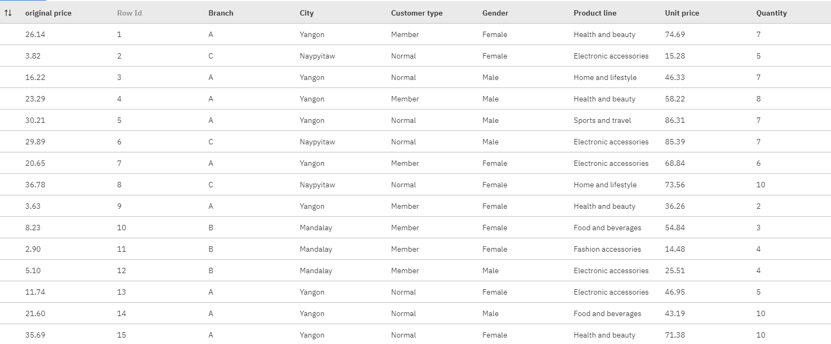

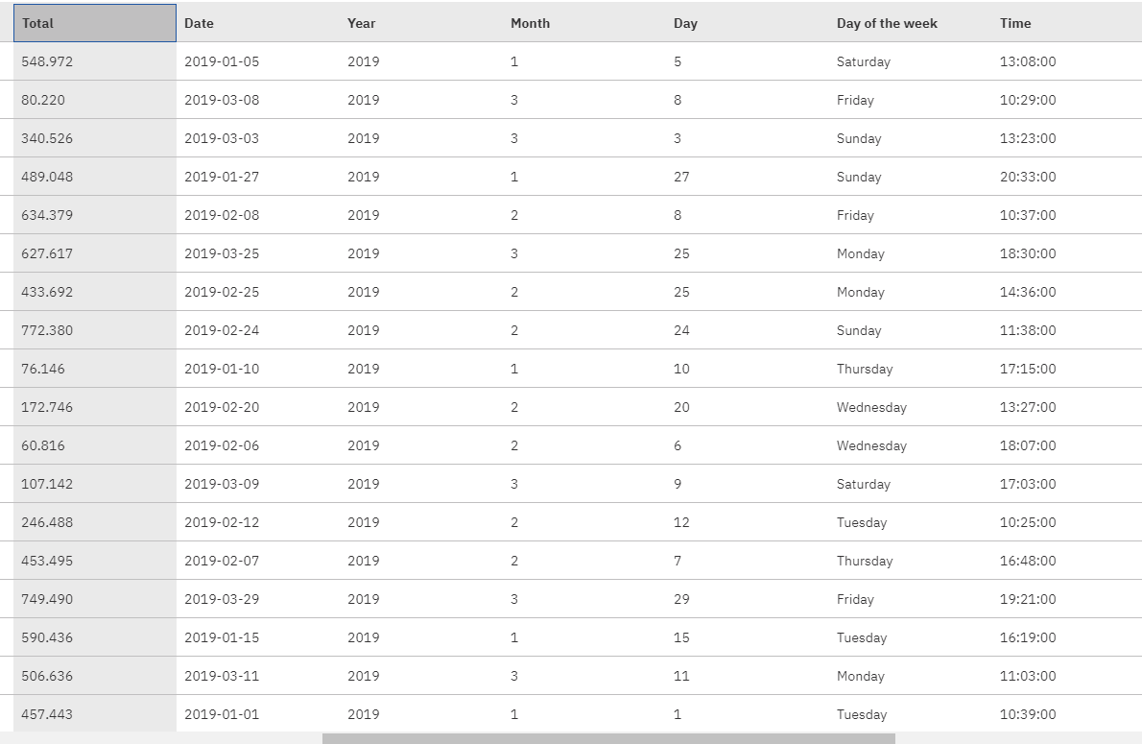

Now let us see the Visualizations

1. Bar Plot

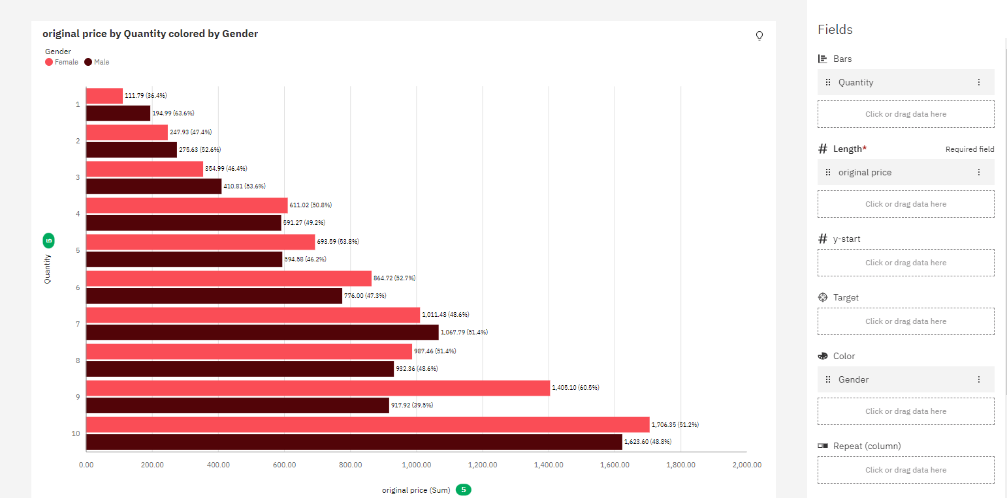

2. Pie Chart

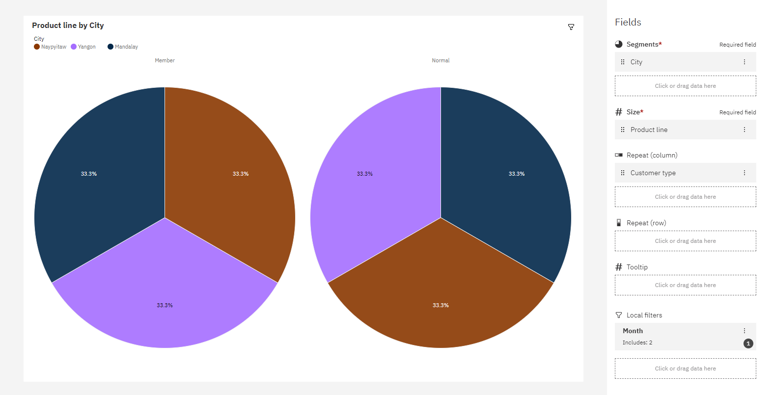

3. Line Chart

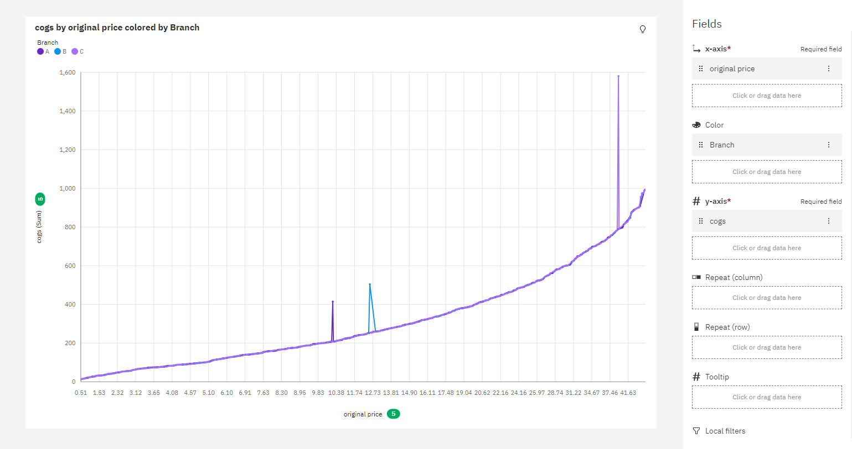

4. Line and Column

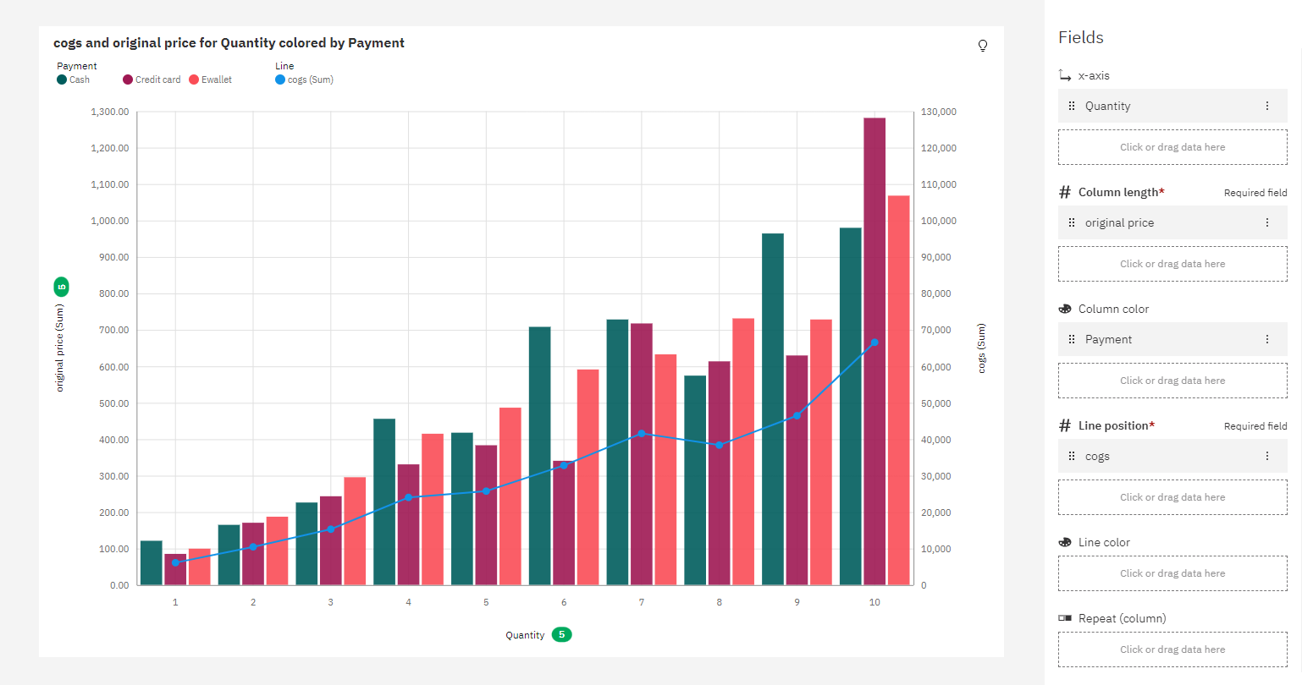

5. Stacked Bar

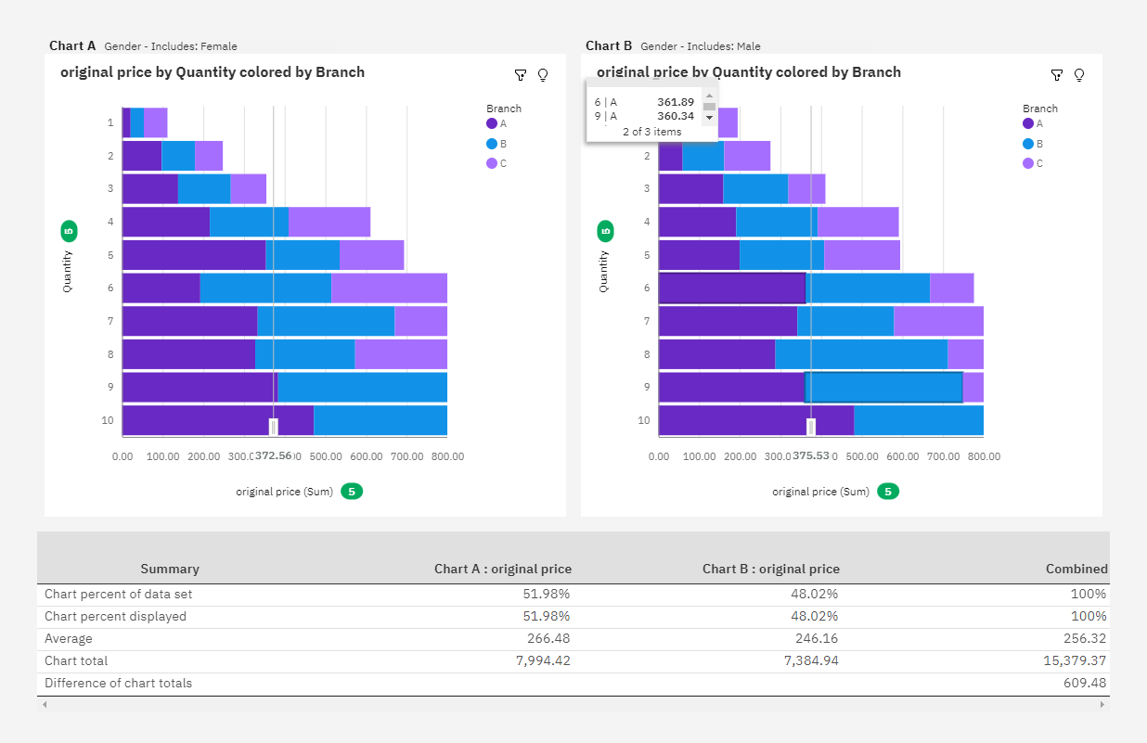

6. Networking

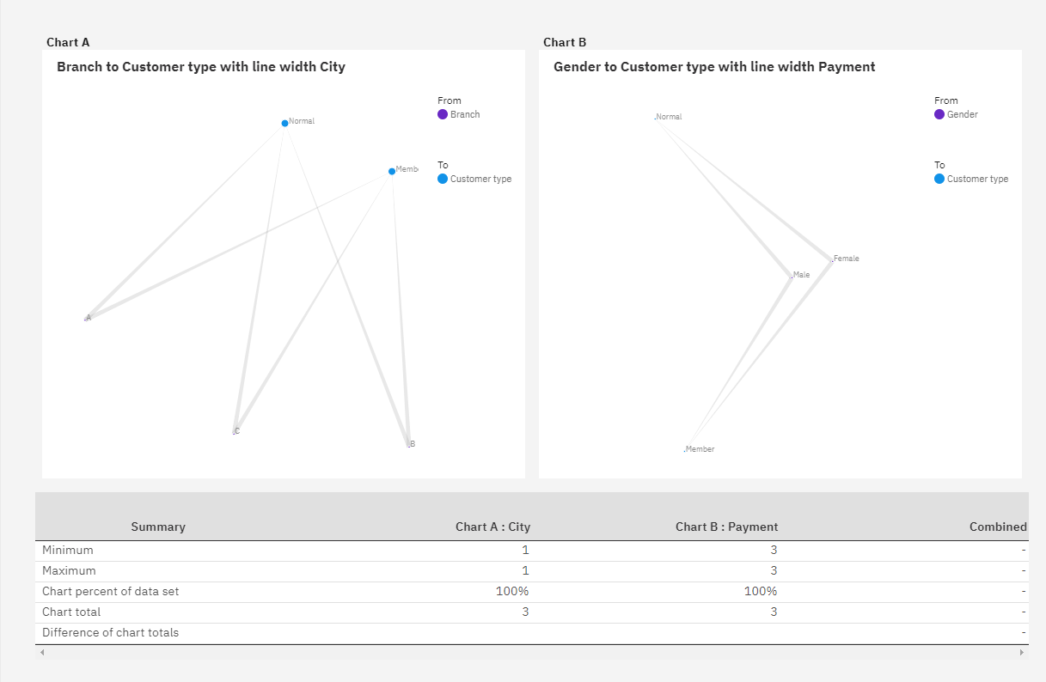

7. Area Plot

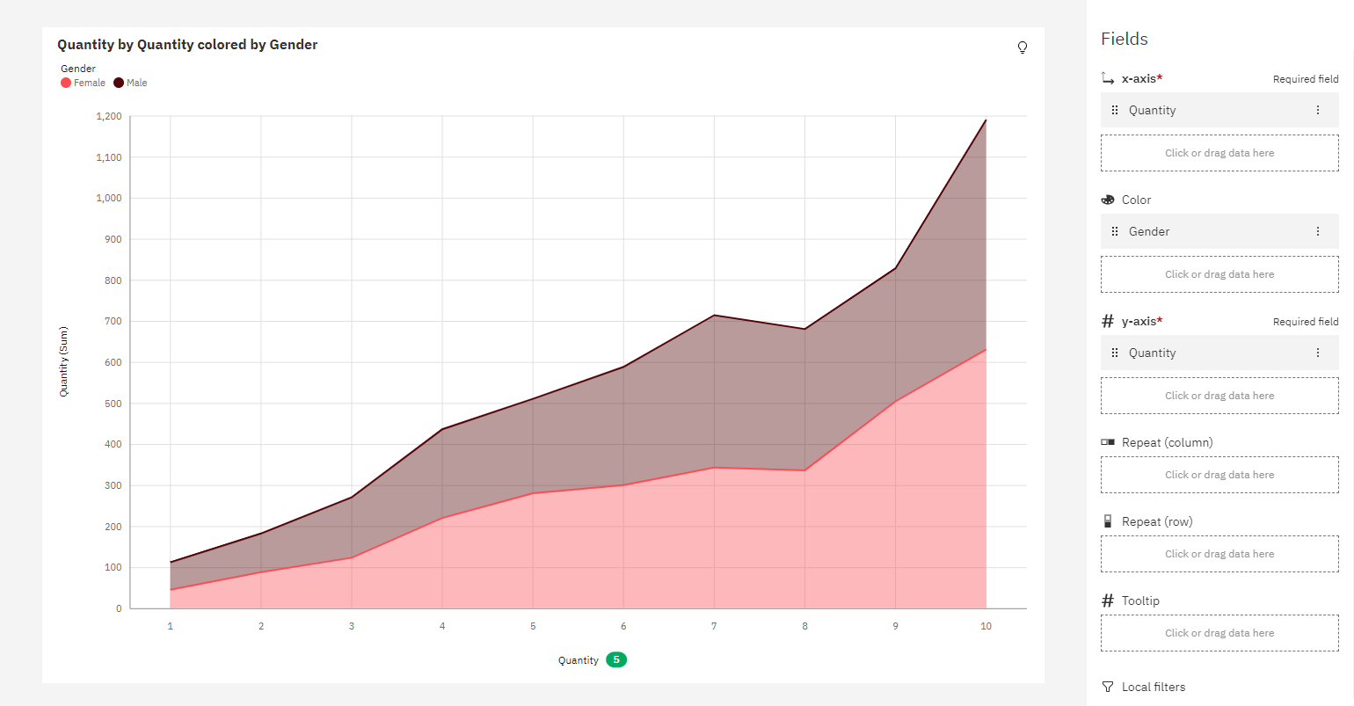

8. Word Cloud

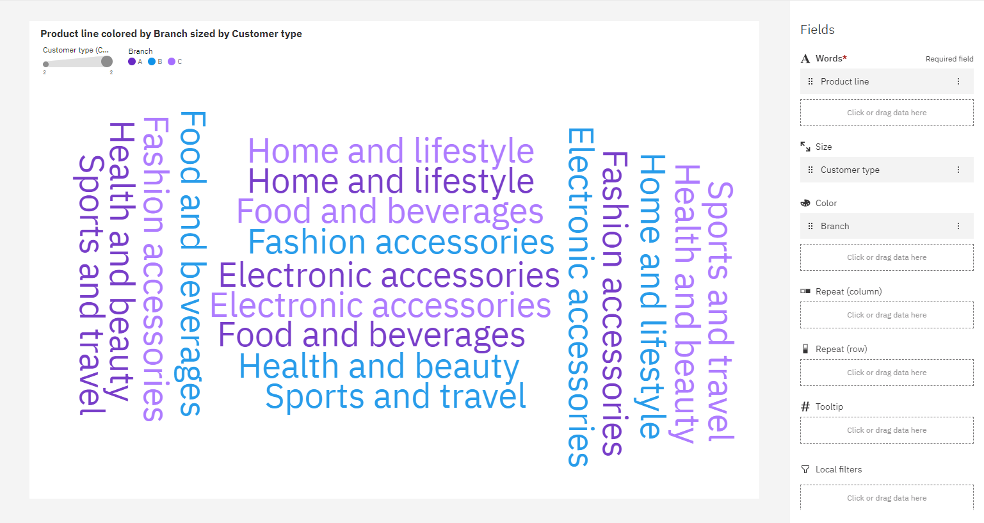

9. Water Fall

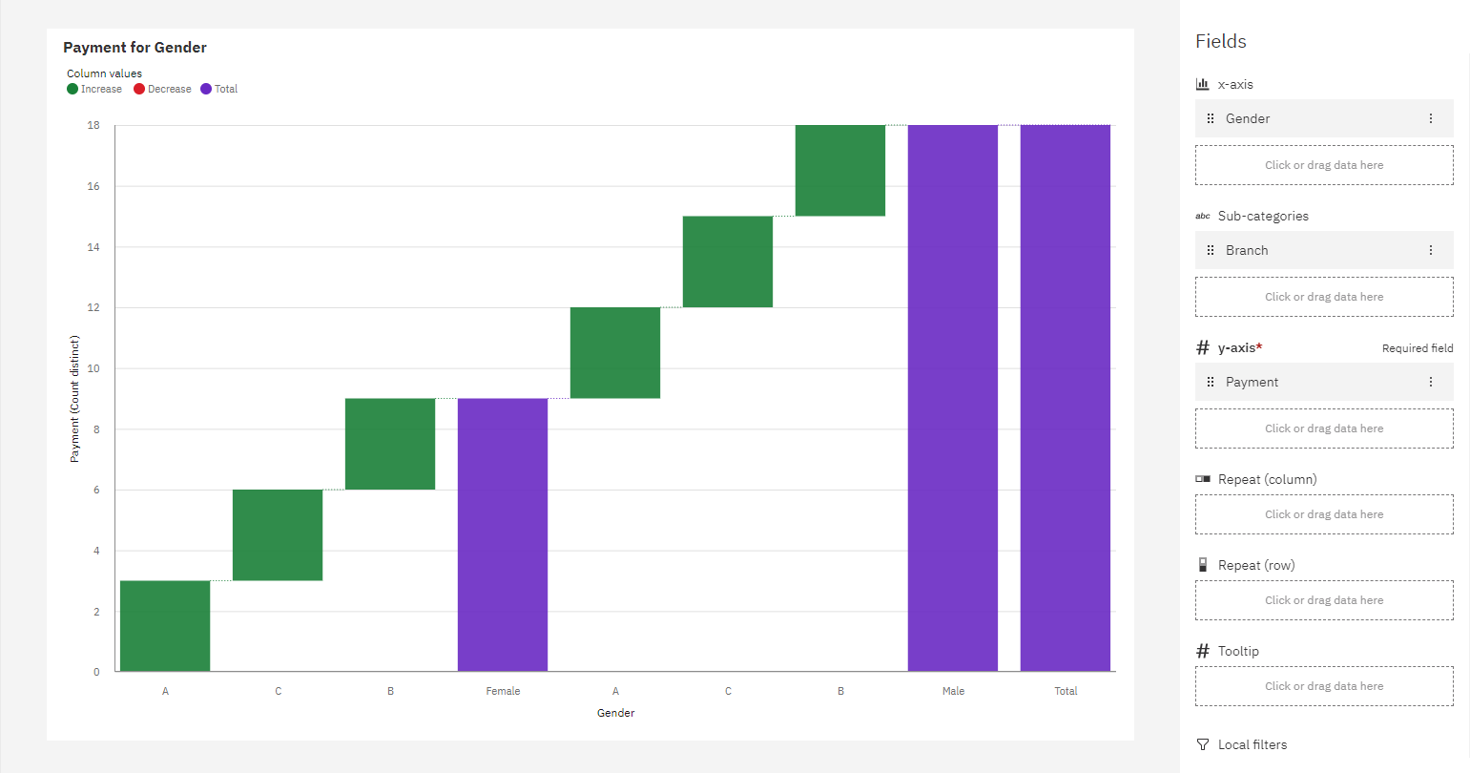

10. Radial Chart

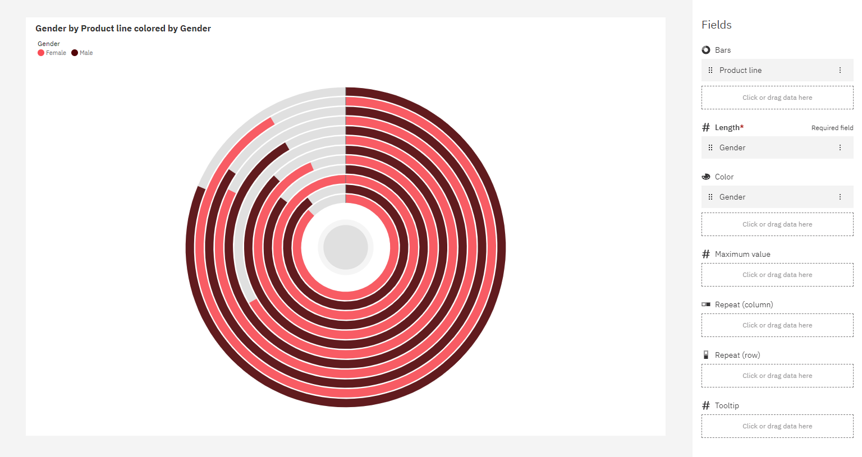

11. Bubble Chart

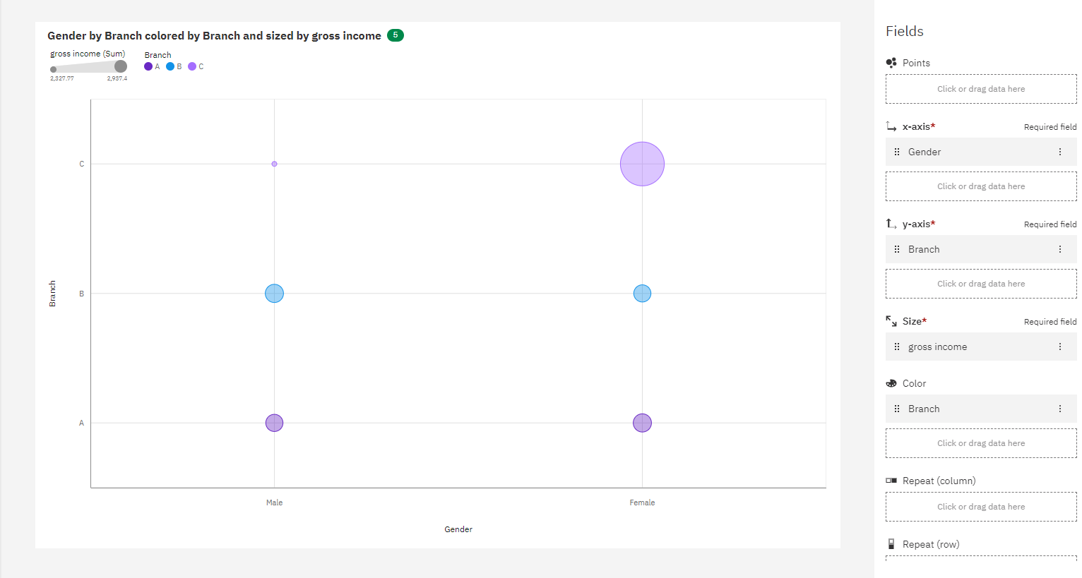

12. Hierarchy Bubble Chart

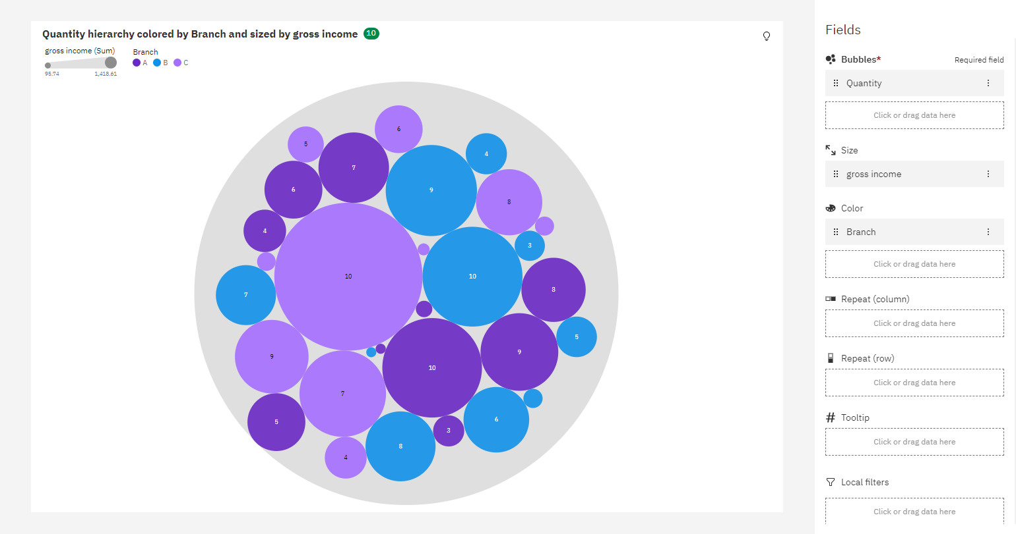

These are some Visualizations from the datamodule